American History II
Unit 2: Imperialism and Isolationism NAME: ____________________________________
******************************************************************************************
Assignment Due Dates:

- Vocabulary 2a: 2/24/16
- Primary Source 1: 2/25/16
- Vocabulary 2b: 3/2/16
- Primary Source 2: 3/2/16
- Discussion Questions: 3/4/16
- Current Event: 3/4/16
- Binder Check: 3/3/16
- Essay: 3/4/16

Quiz Date: 2/26/16
Test Date: 3/4/16
******************************************************************************************
STUDENT OBJECTIVES:
- Understand the reasons why the United States wanted to expand its territories and influence.
- Explain the three types of foreign policy in the early 20th century.
- Explain the causes and effects of the Spanish-American War.
- Explain how becoming a world power impacted the United States.
- Analyze the causes of World War I.
- Explain why America entered the war.
- Examine the Treaty of Versailles.

VOCABULARY TO KNOW:
Unit 2a: Imperialism

- Alfred T. Mahan
- Big Stick Diplomacy
- Dollar Diplomacy
- Emilio Aguinaldo
- Foraker Act
- Gentlemen’s Agreement
- Jingoism
- Jose Marti
- Open Door Policy
- Panama Canal
- “Pancho” Villa
- Philippine Insurrection
- Platt Amendment
- Queen Liliuokalani
- Roosevelt Corollary
- Spheres of Influence
- Teller Amendment
- Treaty of Paris (1898)
- William Seward
- Yellow Journalism

Unit 2b: Isolationism and World War I

- Bolshevik Revolution
- Chicago Race Riot
- Conscientious objector
- Espionage Act
- Fourteen Points
- Great Migration
- John J. Pershing
- League of Nations
- Lusitania
- Nationalism
- Palmer Raids
- Red Scare
- Sacco & Vanzetti
- Sedition Act (1918)
- Selective Service Act
- Self-determination
- Treaty of Versailles
- U-boat
- Western Front
- Zimmermann note

DISCUSSION QUESTIONS:
- How are symbols used to convey ideas?
- Why had neutrality been the dominant foreign policy position of America in the 19th century?
- How does American act as the world’s policeman?
- When is intervention into another country’s affairs appropriate?
- What were the causes of World War I? What were the effects?
- Why was the US neutral at the beginning of the War?
- Was the US really neutral during World War I?
- What trends related to labor were present from the Gilded Age through the 1920s? How do the trends relate to American values?
- Why did the threat of communism produce the Red Scare?
- What conditions cause people to create scapegoats?
- How does war change people?
- Why might some historians refer to World War I and World War II as one conflict with a twenty-year ceasefire?

DBQ ESSAY TOPIC:

Historical Background:
World War I, also known as The Great War, was an international conflict lasting from 1914 to 1918. The driving force that led nations to war was imperialism. It was fought between the Central Powers (consisting mainly of Germany, Austria-Hungary, and Turkey) and the Allied Powers (consisting mainly of France, Great Britain, Italy, Russia, Serbia, the United States, and Japan).

The United States maintained neutrality in the conflict until 1917, when war on Germany was officially declared. American military and economic contributions to the Allied war effort helped to turn the course of the war and eventually led to the defeat of the Central Powers.

Why did the United States enter into WWI after an initial stance of neutrality? How did the U.S. contribute to the Allied cause its entry into the war?

ESSAY GUIDELINES:
- The essay needs to follow the guidelines for an analytical, five-paragraph essay.
- It should have at least five paragraphs, an argumentative thesis statement, specific historical examples, and at least one quotation.
- The length requirement is 2-3 pages, double-spaced, typed, 1-inch margins, 12 point font.
- You must include at least FOUR documents in your essay. Make sure that your cite them!
- Don’t forget to check your spelling and grammar before submitting your final copy. I recommend having another student peer-edit your essay or bringing it into me early to check it over.
- A note on plagiarism: Copying and pasting—either parts or whole essay—from the internet is cheating. If you are discovered to have done this, you will receive a zero on this assignment and a written referral to the office.

CURRENT EVENT REQUIREMENT:
- You must find an article from either a print newspaper or a news website that focuses on one of the following issues:

  - Colonization/De-colonization
  - Border disputes
  - US Foreign Policy
  - War
  - Racial Tensions
  - Espionage
  - Treason
  - Europe
  - Russia
  - Germany

- After you find an article on an approved topic, you need to either print out the article or cut it out of the newspaper.
- Read over the entire article and then complete a current events worksheet on what you read.

******************************************************************************************

At the end of this unit, you will BE ABLE TO:

6 Understand how and why the role of the United States in the world has changed over time.
6.1 Explain how national economic and political interests helped set the direction of United States foreign policy since Reconstruction (e.g. new markets, isolationism, neutrality, containment, homeland security, etc.)
6.2 Explain the reasons for United States involvement in global wars and the influence each involvement has on international affairs (e.g. Spanish-American War, WWI, WWII, Cold War, Korea, Vietnam, Gulf War, Iraqi War, etc.)
7.1 Explain the impact of wars on American politics since Reconstruction (e.g. spheres of influence, isolationist practices, containment policies, first and second Red Scare movements, patriotism, terrorist policies, etc.)

DBQ Essay Documents and questions:

Document 1: Front page of the NY Times, May 8, 1915 Travel Advisory by the Imperial
German Embassy, April 22, 1915
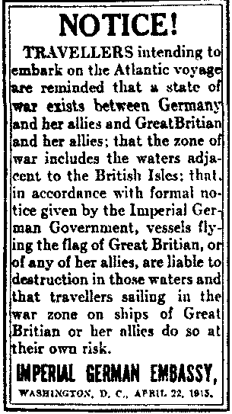
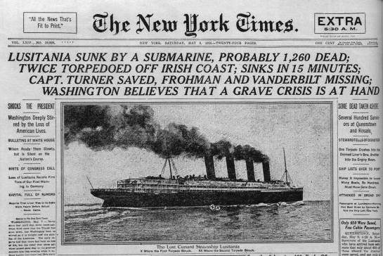

- What was the purpose of the notice from the Imperial German Embassy?

- What effect do you think that the incident described in the NY Times might have had on American public opinion about involvement in the war?

Document 2: Cartoon in response to German U-boat attacks on American ships at sea (1917).
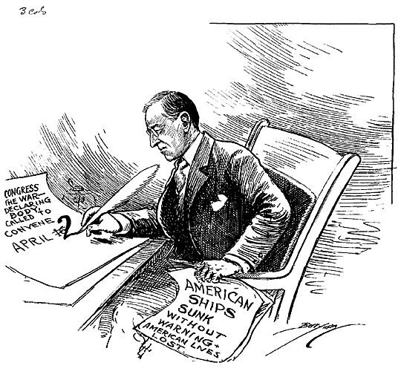

- What is President Wilson doing in the cartoon above?

- What is the reason for his actions in the cartoon above?

Document 3: A 1917 poster from the United States Food Administration
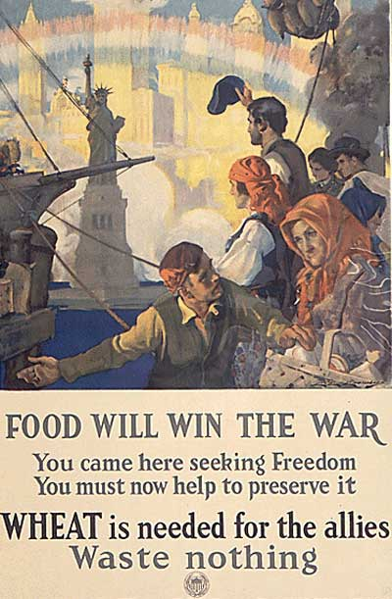

- Who is the target audience for this poster?

- What is the purpose of the poster?

Document 4:
It is a fearful thing to lead this great peaceful people into war, into the most terrible and disastrous of all wars…But the right is more precious than peace, and we shall fight for things which we have always carried nearest to our hearts --- for democracy; for the right of those who submit to authority to have a voice in their own Governments; for the rights and liberties of small nations; for universal dominion of right by such a concert of free peoples as shall bring peace and safety to all nations and make the world itself at last free.
- Woodrow Wilson, speech asking Congress to declare war on Germany (April 2, 1917)

- What are two reasons that Wilson says we must go to war against Germany?

Document 5:
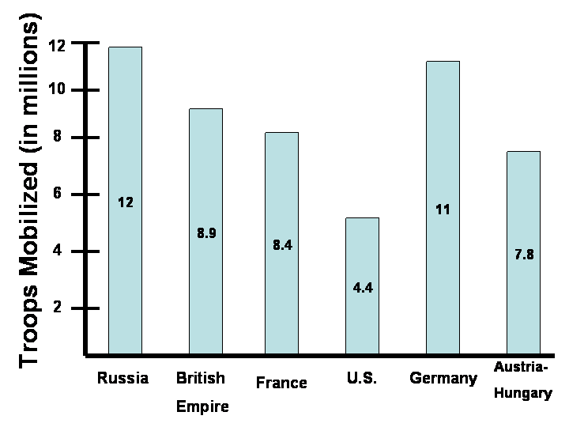

- According to the bar graph, what was one way the U.S. involvement in WWI helped the Allies?

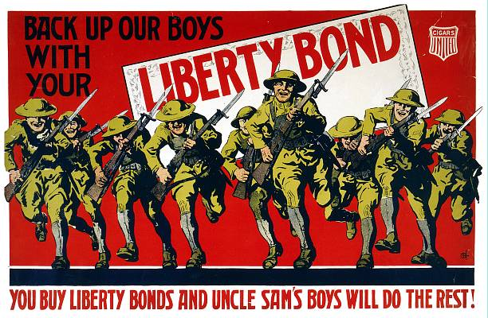
Document 6:

- What is the poster in document 6 asking Americans to do to help the war effort?

- How would this help America with the war effort?

Document 7:
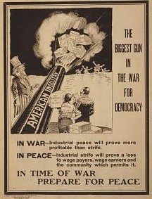

- What is the “Biggest Gun” in the war for democracy?

- How did this “Gun” help the Allies win the war?

Document 8: A Jersey City, New Jersey munitions factory lays in ruins after it was blown up by German spies on July 30, 1916.
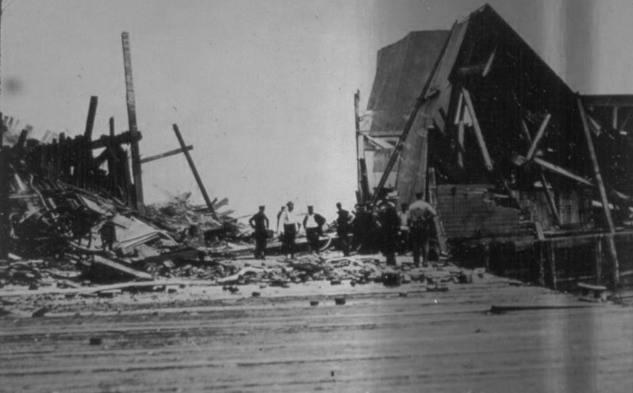
- What is significant about the date of this disaster?

- How might the events at this munitions factory have swayed American public opinion about the war?

*** NOW WRITE YOUR ESSAY IN RESPONSE TO THE QUESTION USING THE DOCUMENTS PROVIDED AS A GUIDE!!!!****

