Enlistment Poster for the Civilian Conservation Corps

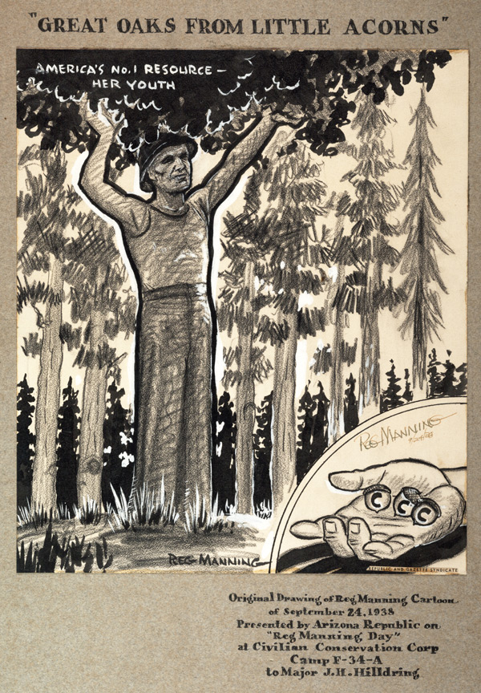
September 24, 1938 Arizona

