“Driving In the Golden Spike”

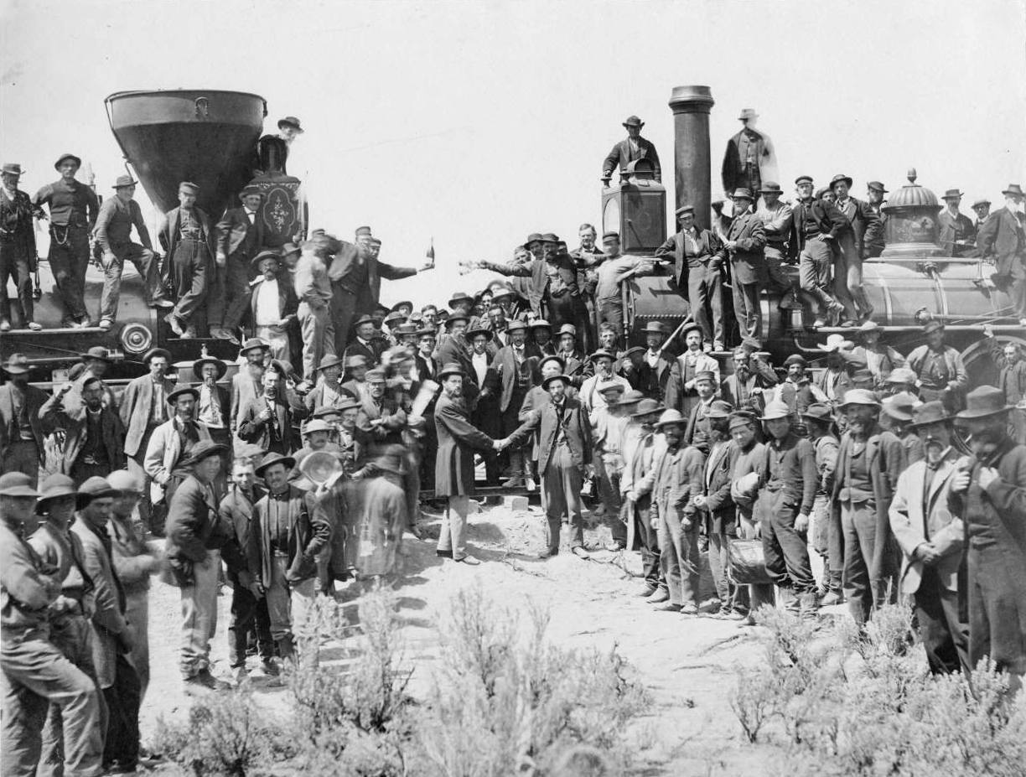
Promontory Summit, Utah May 10, 1869

Photo Credit: A.J. Russell

