Flappers – Changes in Culture

In the 1920s, a new woman was born. She smoked, drank, danced, and voted. She cut her hair, wore make-up, and went to petting parties. She was giddy and took risks, she was a flapper.

The “Younger Generation”
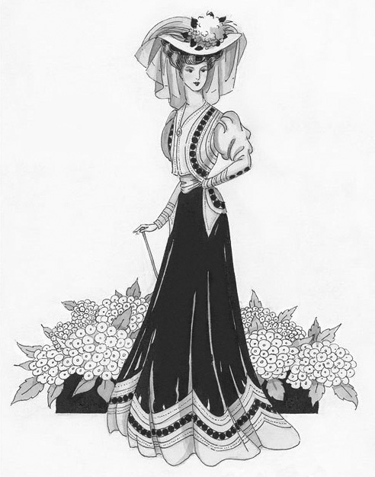
Before the start of World War I, the Gibson Girl was the rage. Inspired Charles Dana Gibson’s drawings, the Gibson Girl wore her long hair loosely on top of her head and wore a long straight skirt and a shirt with a high collar. She was feminine but also broke through several gender barriers for her attire allowed her to participate in sports, including golf, roller skating, and bicycling.

Then World War I started. The young men of the world were being used as cannon fodder for an older generation’s ideals and mistakes. The attrition rate in the trenches left few with the hope that they would survive long enough to return home. They found themselves inflicted with an “eat-drink-and-be-merry-for-tomorrow-we-die-spirit.” Far away from the society that raised them, and faced with the reality of death, many searched (and found) extreme life experiences before they entered the battlefield.

When the war was over, the survivors went home and the world tried to return to normalcy. Unfortunately, settling down in peacetime proved more difficult than expected. During the war, the boys had fought against both the enemy and death in faraway lands; the girls had bought into the patriotic fervor and aggressively entered the workforce. During the war, both the boys and the girls of this generation had broken out of society’s structure; they found it very difficult to return.

They found themselves expected to settle down in the humdrum routine of American life as if nothing had happened, to accept the moral dicta of elders who seemed to them still to be living in a Pollyanna land of rosy ideals, which the war had killed for them. They couldn’t do it, and they very disrespectfully said so.

Women were just as anxious as the men to avoid returning to society’s rules and roles after the war. Young women decided that they were not willing to waste away their young lives waiting idly for spinsterhood; they were going to enjoy life. The “Younger Generation” was breaking away from the old set of values.

The “Flapper”
The term “flapper” first appeared in Great Britain after World War I. It was there used to describe young girls, still somewhat awkward in movement who had not yet entered womanhood. In the June 1922 edition of the Atlantic Monthly, G. Stanley Hall described looking in a dictionary to discover what evasive term “flapper” meant:

“The dictionary set me right by defining the word as a fledging, yet in the nest, and vainly attempting to fly while its wings have only pinfeathers; and I recognized that the genius of “slanguage” had made the squab the symbol of budding girlhood.”

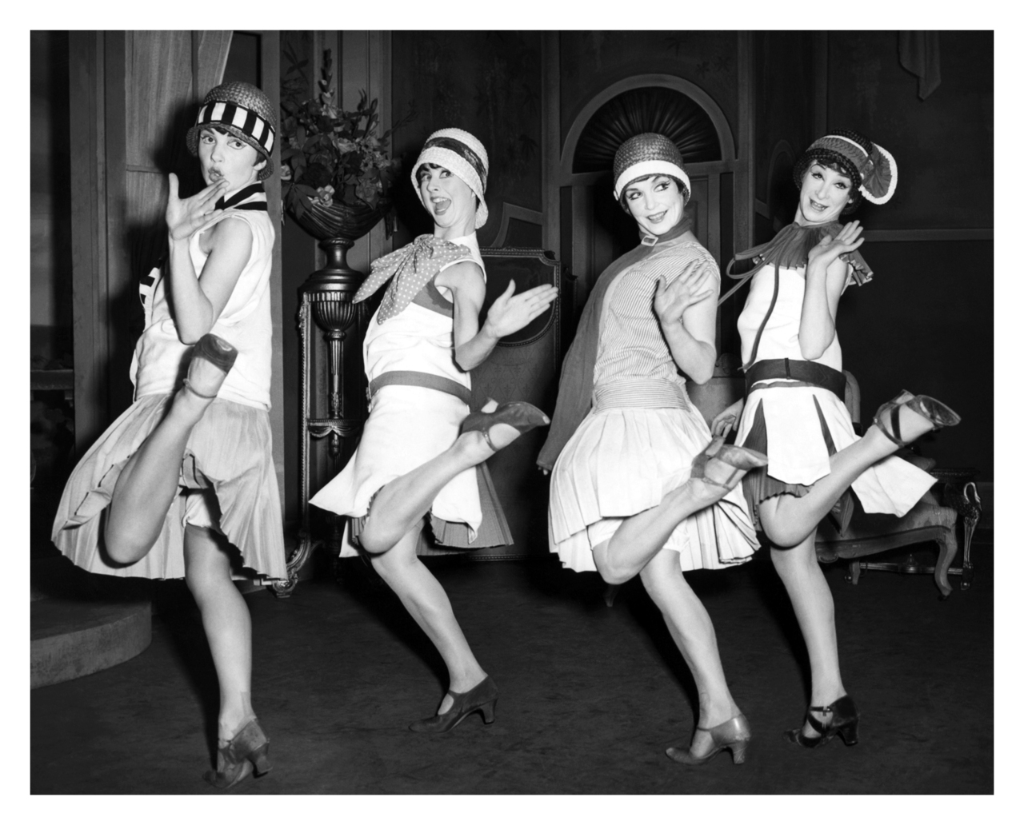
Authors, such as F. Scott Fitzgerald, and artists, such as John Held Jr., first used the term to the U.S. half reflecting and half creating the image and style of the flapper. Fitzgerald described the ideal flapper as “lovely, expensive, and about nineteen.” Held accentuated the flapper image by drawing young girls wearing unbuckled galoshes that would make a “flapping” noise when walking.

“In America, a flapper has always been a giddy, attractive and slightly unconventional young then who,” in [H.L.] Mencken’s words, “was a somewhat foolish girl, full of wild surmises and inclined to revolt against the precepts and admonitions of her elders.” Flappers had both an image and an attitude.

Flapper Image
The Flappers’ image consisted of drastic – to some, shocking – changes in women’s clothing and hair. Nearly every article of clothing was trimmed and lightened in order to make movement easier.

It is said that girls “parked” their corsets when they were to go dancing. The new, energetic dances of the Jazz Age, required women to be able to move freely, something the “ironsides” didn’t allow. Replacing the pantaloons and corsets were underwear called “step-ins.”

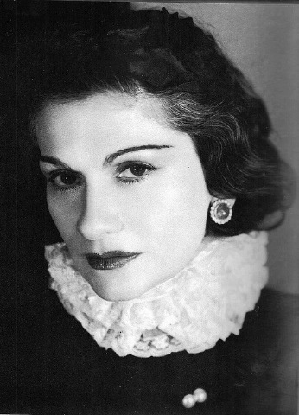
The outer clothing of flappers is even still extremely identifiable. This look, called “garcome” (“little boy”), was instigated by Coco Chanel. To look more like a boy, women tightly wound their chest with strips of cloth in order to flatten it. The waists of slapper clothes were dropped to the hipline. She wore stockings – made of rayon (“artificial silk”) starting in 1923 – which the flapper often wore rolled over a garter belt.

The hem of the skirts also started to rise in the 1920s. at first the hem only rose a few inches, but from 1925-1927 a flapper’s skirt fell just below the knee.

The skirt comes just an inch below her knees, overlapping by a faint fraction her rolled and twisted stocking. The idea is that when she walks in a bit of a breeze, you shall now and then observe the knee (which is not rouged – that’s just newspaper talk) but always an accidental, Venus-surprised-at-the-bath sort of way.

The Gibson Girl, who prided herself on her long, beautiful, lush hair, was shocked when the flapper cut hers off. The short haircut was called the “bob” which was later replaced by an even shorter haircut, the “shingle” or “Eton” cut. The shingle cut was slicked down and had a curl on each side of the face that covered the woman’s ears. Flappers often finished the ensemble with a felt, bell shaped hat called a cloche.

Flapper also started wearing make-up, something that had previously been only worn by loose women. Rouge, powder, eye-liner, and lipstick became extremely popular.

Beauty is the fashion in 1925. She is frankly, heavily made up, not to imitate nature, but for an altogether artificial effect – pallor mortis, poisonously scarlet lips, richly ringed eyes – the latter not so much debauched (which was the intention) as diabetic.

Flapper Attitude
Stark truthfulness, fast living, and sexual behavior characterized the flapper attitude. Flappers seemed to cling to youth as if it were to leave them at any moment. They took risk and were reckless.

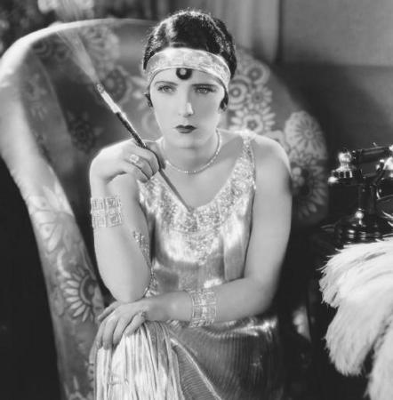
They wanted to be different, to announce their departure from the Gibson Girl’s morals. So they smoked. Something only men had done previously. Their parents were shocked.

Smoking wasn’t the most outrageous of the flapper’s rebellious actions. Flappers drank alcohol. At a time when the United States had outlawed alcohol (Prohibition), young women were starting the habit early. Some adults didn’t like to see tipsy young women. Flappers had a scandalous image as the “giddy flapper, rouged and clipped, careening in a drunken stupor to the lewd strains of a jazz quartet.”

The 1920s was the Jazz Age and one of the most popular past-times for flappers was dancing. Dances such as the Charleston, Black Bottom, and the Shimmy were considered “wild” by older generations. As described in the May 1920 edition of the Atlantic Monthly, flappers “trot like foxes, limp like lame ducks, one-step like cripples, and all to the barbaric yawp of strange instruments which transform the whole scene into a moving-picture of a fancy ball in bedlam.” For the Young Generation, the dances fit their fast-paced life-style.

For the first time since the train and the bicycle, a new form of faster transportation was becoming popular. Henry Ford’s innovations were making the automobile an accessible commodity to the people. Cars were fast and risky – perfect for the flapper attitude. Flappers not only insisted on riding in them; they drove them.

Unfortunately for their parents, flappers didn’t just use cars to ride in. The back seat became a popular location for the new popular sexual activity, petting. Others hosted petting parties. Though their attire was modeled after little boys’ outfits, flappers flaunted their sexuality. It was a radical change from their parents’ and grandparents’ generations.

The End of Flapperhood
Though many were shocked by the flapper’s skimpy attire and licentious behavior, a less extreme version of the flapper became respectable among the old and the young. Some women cut off their hair and stopped wearing their corsets, but didn’t go to the extreme of flapperhood.

At the end of the 1920s, the stock market crashed and the world was plunged into the Great Depression. Frivolity and recklessness was forced to come to an end. However, much of the flapper’s changes remained.

In the 1920s, flappers broke away from the Victorian image of womanhood. They dropped the corset, chopped their hair, dropped layers of clothing to increased ease of movement, wore make-up, created the concept of dating, and became a sexual person. They created what many consider the “new” or “modern” woman.

Flapper Questions (answer in COMPLETE SENTENCES on a separate sheet of paper):
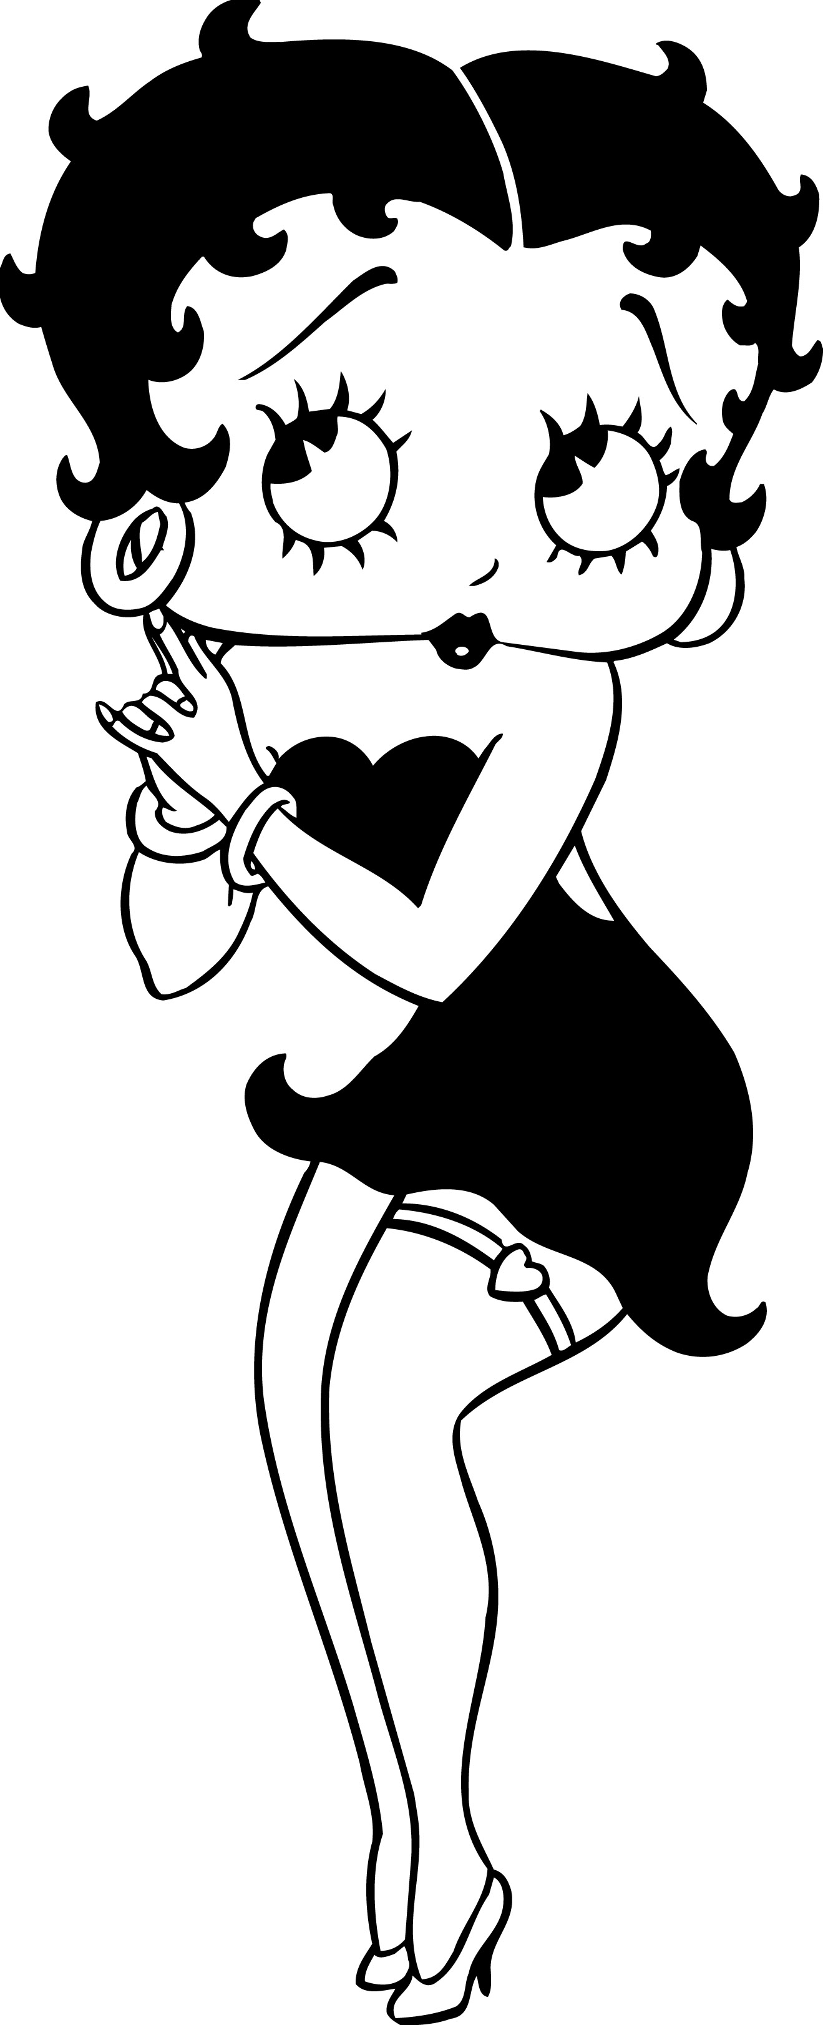
- Betty Boop (image to the left) made her first appearance on August 9, 1930, in the cartoon Dizzy Dishes. She is a symbol of the “new woman.” Describe the similarities of her appearance and the image of the 1920s flapper.

- How did the role of women in society change from the late 1880’s of housewives to the 1920’s flappers? Cite at least 3 specific changes.

- Describe the clothing of the “new woman” of the Twenties.

- How did the new fashions of the Twenties dictate behavior?

- Name a new fashion trend, or fad, today. What behavior could this new fashion dictate?

- Laws were made up and groups were formed to combat the “flapper.” In Chicago, women could be fined from $10 to$100 for exposing arms and legs. Utah made a law, which forbad women to wear dresses anymore than three inches above their ankle. The Anti-Flirt League was formed to battle the “flapper.” Women did not have legal protection from gender discrimination. Therefore, many women were fired or not hired due to their “flapper” status.

Imagine you are a woman of the Twenties who embraces the flapper culture. You were fined $50 for wearing a sleeveless shirt and fired from your job. Write an editorial (at least 100 words) to a local newspaper defending your flapper status and beliefs.

