Photograph of a Hooverville

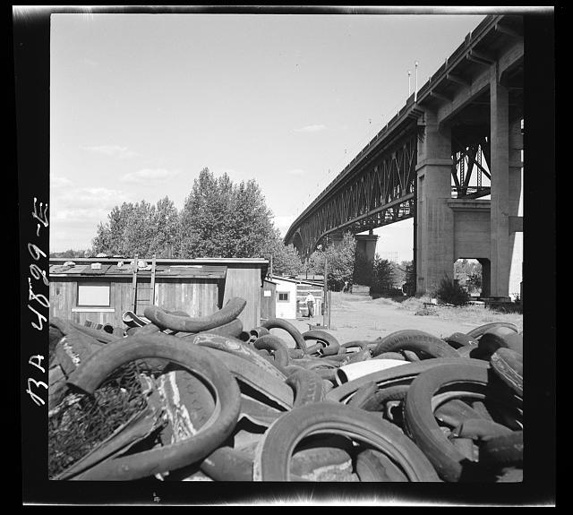

Photo Credit: Arthur Rothstein in 1936 Portland, Oregon

