Immigration Figures for 1903
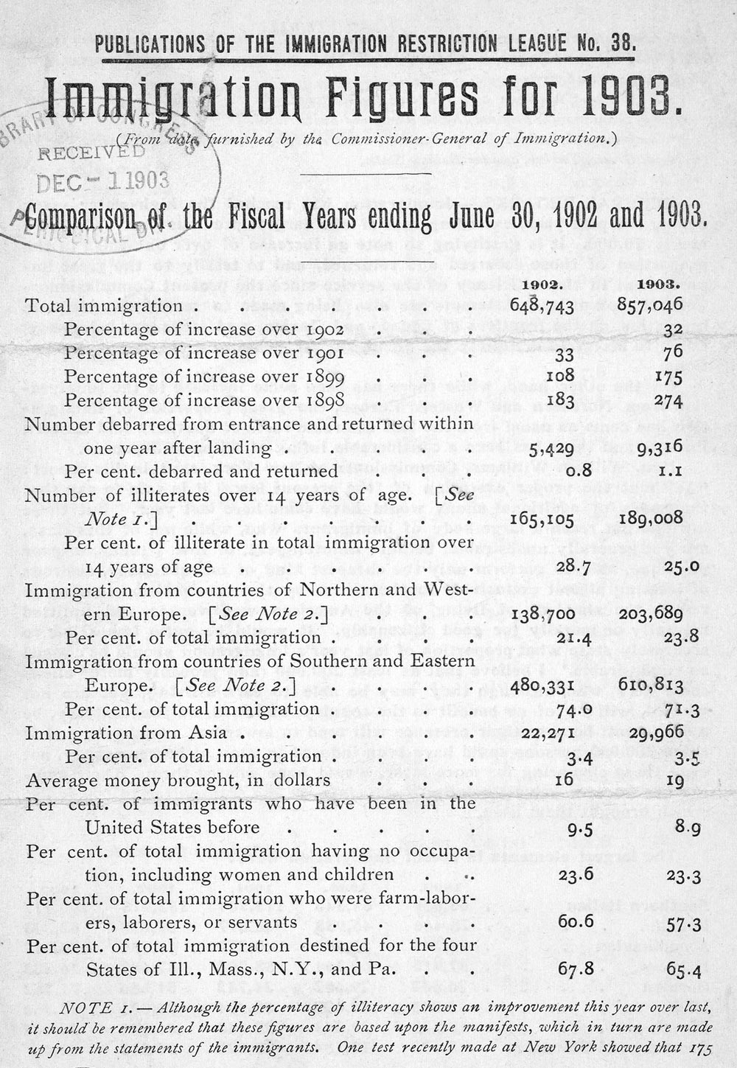
Immigration Restriction League, “Immigration Figures for 1903”, Boston, 1903

