Industrial Workers of the World
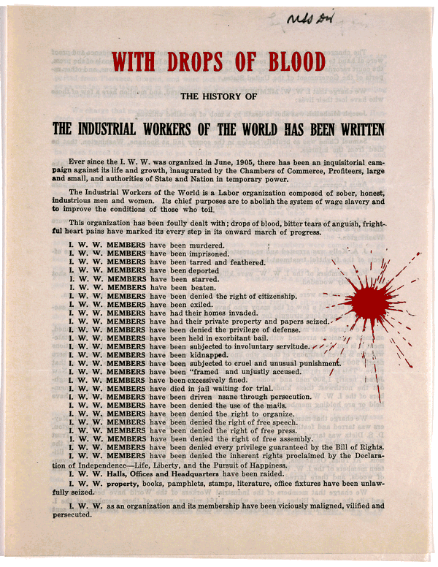
1919 Wm. Haywood. Secretary. Chicago

