Headquarters of the National Anti-Suffrage Association
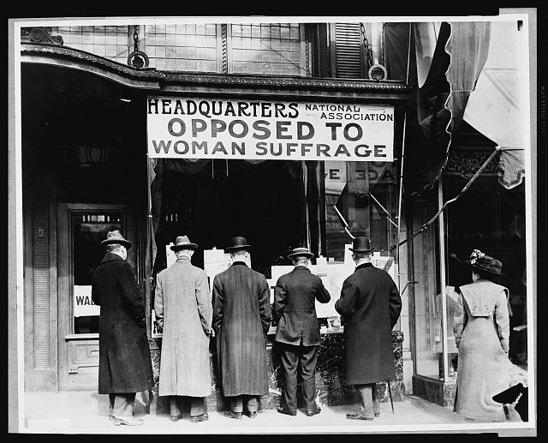
Ca. 1911 Photo credit: Harris & Ewing

