“Next!”
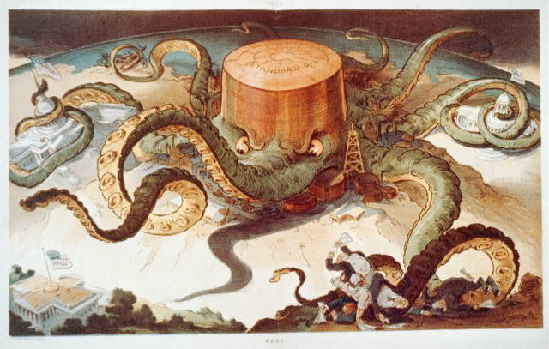
Creator(s): Keppler, Udo J., 1872-1956, artist
Date Created/Published: N.Y. : J. Ottmann Lith. Co., Puck Bldg., 1904 September 7

