“The Americanese Wall”
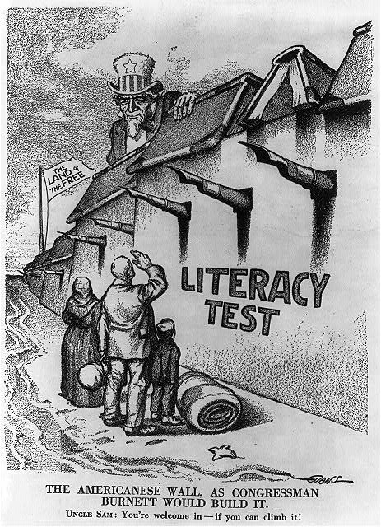
Ca. 1916 New York City, New York

Created by the Federal Art Project

