“The Chinese Invasion”
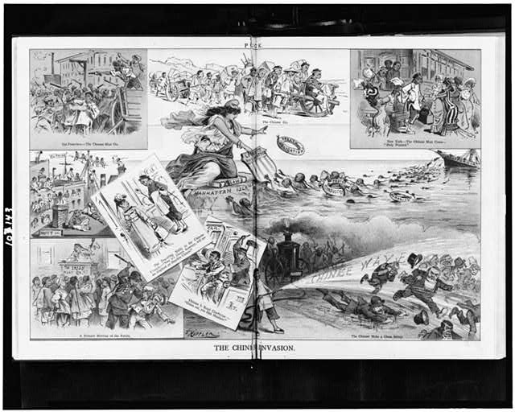
Author: Joseph Ferdinand Keppler 1880

Composite of nine cartoons, each separately captioned, on Chinese immigrants in the United States, including New York City and San Francisco.

