THE GROWTH OF INDUSTRY

The United States experienced rapid industrial growth between 1860 and 1900. During the Civil War, factories turned out weapons, war materials, farm equipment, and different kinds of machinery. In the years after the war, more factories were built, people moved to the cities to get jobs, and inventions were made. New products came into use, the railroad system was expanded, and new stores and businesses appeared. A wave of immigrants poured into the United States, and poured a source of cheap labor.

Directions: The sentences below give information about the development of the United States into a leading industrial nation. Fill in the spaces with the words from the list which best complete the statements.

Tariffs
Money
Exported
World
Market
Captains of Industry
Natural resources
Sherman Anti-trust Act
Mass production
Shares of stock
Assembly line
Stockholders
Standardized
Population
Immigrants
Corporation
Machines
Monopolies
Mail order
Steamship
Thomas A. Edison
Farm products
Northeast
Industrial nation
Manufacturing

- The amount of ________________________________ in the United States more than doubled between 1860 and 1900.
- Manufacturers used the railroads to send their goods to ____________________________.
- America’s rich supply of ______________________________ provided industry with the raw materials needed to turn out a wide variety of finished goods.
- Wealthy Europeans and Americans eagerly invested ____________________________ in new businesses in the United States.
- High ___________________________ protected American industry from foreign competition.
- Millions of ________________________________ came to the United States, and provided factory owners with an eager supply of workers.
- The steadily increasing _____________________________ of the United States gave manufacturers an expanding market for their goods
- Products were made by power-driven ___________________________ operated by factory workers.
- The railroad, a better sailing ship, the __________________________________ telegraph, and telephone reduced the time and cost of transportation and communication.
- A new form of business called a _______________________________ developed in the years after the Civil War.
- Corporations were able to raise large sums of money because many people bought ___________________________in the business.
- The people who purchased shares of stock were called _____________________________.
- A corporation had enough money to build huge factories, but expensive machinery, and sell products across the county and around the ______________________________.
- Some big businesses became __________________________________ after they ended competition by driving out smaller businesses.
- The government finally acted to control the power and abuses of big business by passing such laws as the _________________________________________________ and Clayton Anti-Trust Act.
- American industries developed the system of ________________________________, and turned out large quantities of goods at low prices.
- _____________________________________, or interchangeable, parts were assembled into finished articles.
- Each worker along an _____________________________ attached another part to an article moving past them on a conveyor belt.
- The general store was replaced by specialty shops, chain stores, department stores, and ________________________________ houses.
- Andrew Carnegie, John D. Rockefeller, and other “________________________________” took control of steel, oil, and other industries during the late 1800s.
- Inventors led by __________________________ created a wide variety of new products for consumers.
- By the late 1800s, the United States _________________________________ more manufactured goods than it imported.
- The states which did the most manufacturing were in the _____________________________ and Midwest.
- By 1900, the value of manufactured goods in the United States was twice that of the nation’s _______________________________.
- The United States became the leading _____________________________ in the world.

Map Exercise: The map below shows industrial regions of the United States in the year 1900. Notice that the manufacturing centers are located in the Midwest and the Northeast. Industry was gradually expanding into the South and West, but the economies of these sections continued to be based mainly on agriculture and mining.

On the map: Locate and label each of the following manufacturing centers: Boston, New York, Philadelphia, Baltimore, Buffalo, Pittsburgh, Cleveland, Detroit, Cincinnati, Chicago, and St. Louis.

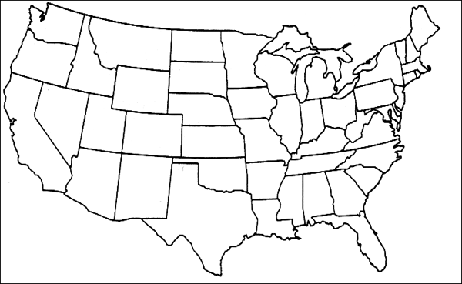

Word Search: One of the reasons why the United States became a leading industrial nation was its abundant supply of natural resources. The most important of these are listed below. Find and circle them on the puzzle.

Fertile soil Forests Sand and Gravel Zinc
Water power Coal Bauxite Lead
Copper Iron ore Phosphorus Petroleum
Potash Uranium Stone Natural gas

J V O T D R Y A T M C Q J Y V M
J S L P A F O A T U J J Z F Q U
X A I D I O S P H E I W X F R I
F G O B R R A O W L B A P S Q N
L L S A O E N T T O A T H M H A
Q A E M N S D A E R U E O B I R
X R L Z O T A S N T X R S N Z U
O U I F R S N H O E I P P V L V
A T T Y E D D Q T P T O H N E V
C A R P Y C G F S X E W O G A K
P N E E M R A Y H X Z E R T D V
O Q F O X U V F L F S R U M P C
V Z Y R Q H E L K A V G S N A Q
V O P G N L L O T Q O Q K L J N
Q A E F R E P P O C P C G R O R
J Q R I M Q R Z Z I N C K X A T

Graph Exercise:
- The growing population of the United States in the second half of the 19th century meant there were more and more consumers to buy manufactured goods. Put dots on the graph to show the rise in population between 1850 and 1900. Draw lines to connect the dots
80,000,000
60,000,000
40,000,000
20,000,000
0
U.S. Population
1850: 23,191,876
1860: 31,443,321
1870: 39,818,449
1880: 50,155,783
1890: 62,947,714
1900: 75,994,575

- Large numbers of workers were needed to keep up with the ever-increasing demanding for manufactured goods. A steady stream of people left farming regions and moved to the cities to take jobs in factories. In 1850, 85% of the American people lived in rural areas, while only 15% lived in urban areas. But by 1900, the population had shifted so that 60% lived in rural areas and 40% in urban areas. Construct two circle graphs which show the shift of the population from rural to urban areas. Divide the circle graphs into “rural” and “urban” segments, and label them. The above mentioned percentages on the graphs.

- Over 16 million immigrants came to the United States between 1850 and 1900. Many took jobs in American industries. Shade the bar graph to show the number of immigrants who arrived in this country during each ten-year period.

