“The Protectors of Our Industries”
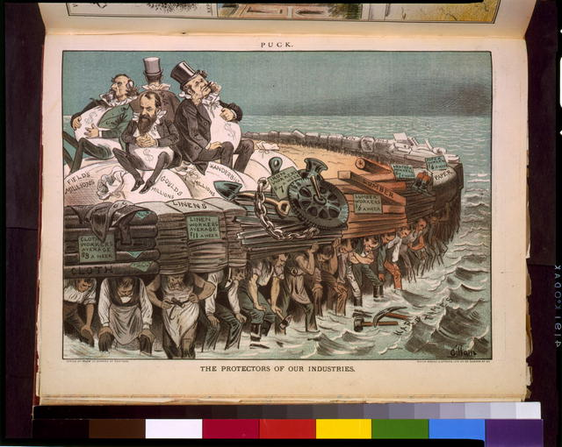
Creator(s): Gillam, Bernhard, 1856-1896, artist
Date Created/Published: N.Y. : Published by Keppler & Schwarzmann, 1883 February 7.

