WORLD WAR II

World War II, which lasted from 1939 until 1945, took more lives, cost more money, and destroyed more property than any other war in history. An estimated 16 million men died on the battlefields of Europe, North Africa, and Asia, and in the Atlantic Ocean, Pacific Ocean, and Mediterranean Sea. More than 50 countries were involved at a cost in excess of 1 trillion dollar. A new era in warfare was ushered in by huge tanks, fast-moving armies, massive air strikes, large-scale sea battle, missiles, and atomic bombs.

Directions: Here is an opportunity to compare your decision-making skills with those of some of the key figures who influenced the course of World War II. Decide what you would have done if you had been in the position of such people as General Dwight D. Eisenhower or President Harry S. Truman during the war years. Consider the circumstances described in the background information for each question. Then circle either choice a, b, or c. Afterwards, you will be told which choice was actually made during the war.

Background for Question 1
During 1938 and the first part of 1939, Germany seized two neighboring countries, Austria, and Czechoslovakia. Germany also stood behind Italy’s invasion of Albania. Next, the Germans advanced into Poland. Great Britain and France, fearing that Adolf Hitler might be trying to conquer all of Europe, decided it was time to take a stand, and so they declared war.

Question 1
In a time of crisis, such as existed in September 1939, the United States Congress can pass legislation which sets a course of action. If you were a Congressman when Great Britain and France declared war on Germany, which of the following would you vote to do?
- Declare war on Germany and send troops to help the British and French.
- Send supplies, but no military forces, to Great Britain and France.
- Remain totally neutral.

Background for Question 2
Despite the fact that the United States and Japan were not at war, the Japanese launched a surprise attack on December 7, 1941, against American air and naval forces at Pearl Harbor, Hawaii. Several hundred enemy planes took part in the one hour and forty-five minute raid. The result was the destruction of many American planes and ships, and the killing of more than two thousand men. Japan emerged with an overwhelming military advantage in the Pacific region.

Question 2
After the attack on Pearl Harbor, Congress approved President Franklin D. Roosevelt’s request for a declaration of war against Japan. The United States had to quickly raise a large military force. If you were a Congressman, which of the following would you do to provide the necessary manpower for the army, navy, air force, and marines?
- Vote for a Selective Service Act calling for the drafting of men between the ages of 18 and 45.
- Support a Selective Service Act providing for the drafting of both men and women.
- Ask for volunteers instead of using a draft.

Background for Question 3
The map of Europe below shows territory controlled by the Axis Powers (Germany and Italy) at the height of their conquests. American and other Allied forces were concentrated in Great Britain at this time. Countries which remained neutral are represented on the map by diagonal lines.
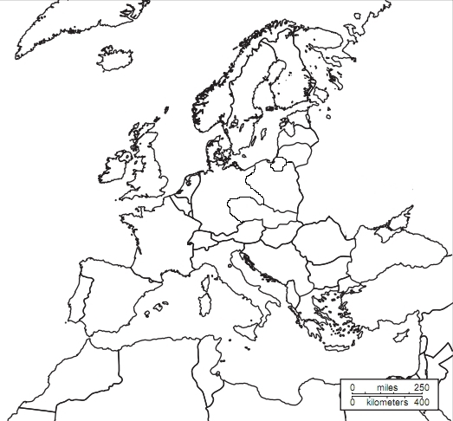

Question 3
If you were General Dwight D. Eisenhower, commander of the Allied forces in Great Britain, which strategy would you use to defeat Germany and Italy?
- Defeat Axis troops and tank divisions in North Africa, and then move across the Mediterranean Sea and attack Italy. While attacking Italy, send a second army across the English Channel to northern France and force the Germans to retreat.
- Transport most of the Allied forces across the North Sea to Denmark. Then move south into Germany.
- Leave half of all Allied soldiers in Great Britain to fight a defensive war. Send the other half to the Pacific region to defeat Japan.

Background for Question 4
While the Allies were trying to push back German and Italian armies in Europe, another campaign was taking place in the Pacific. The fighting there involved the United States and Japan. Japan had conquered parts of Asia and a large number of Pacific islands. It was left mainly to the United States to recapture the lost territory and force the Japanese to surrender.
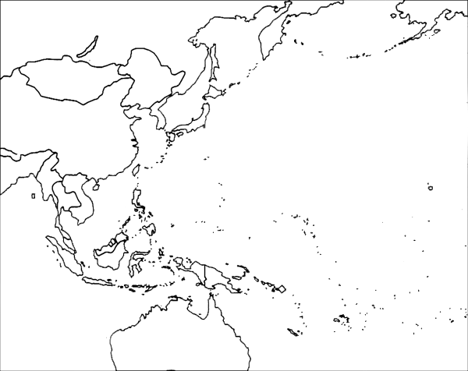
Farthest extent of Japanese control
Question 4
What strategy would you use to defeat Japan if you were General Douglas MacArthur, chief of Allied forces in the Pacific?
- Attack Japan by crossing the North Pacific from Alaska.
- Starting from the Hawaiian Islands, drive back the Japanese by recapturing islands now under their control. Continue taking these islands until close enough to attack Japan itself.
- Send nearly all American forces in the Hawaiian Islands around the southern end of Australia to Southeast Asia. Move north into China, then launch a direct assault on Japan.

Background for Question 5
After several years of hard fighting, the Americans drove enemy forces to within a few hundred miles of Japan. This brought Japanese cities and military targets within range of U.S. bombers. Meanwhile, in the United States, Allied scientists completed work on the world’s first atomic bomb. President Roosevelt died soon after beginning his fourth term, and Harry S. Truman succeeded him.

Question 5
If you were President Truman, which action would you take to bring about the final defeat of Japan?
- Drop the atomic bombs on Japan.
- Keep forcing the enemy to retreat until it is possible to invade Japan itself.
- Blockade Japan to prevent the importation of needed supplies.
Contest Rules: Fill in missing letters in the words, names, and terms which complete the following sentences. The winners of this contest will be the people with the most correct answers after 25 minutes.

- World War II began in September 1939 when Great Britain and France declared war on Germany, two days after German troops swept into __ __ L __ __ D.
- The British and French ended their policy of appeasement, whereby they had given in on numerous occasions to Adolf Hitler’s demands for more __ A __ __ __ in Europe.
- Great Britain, France, and the countries siding with them were known as the __ __ L __ __ S.
- Germany, Italy, and Japan were the chief __ X __ __ __ __ __ __ __ __.
- The Germans overran most of Europe during the early years of the war because their armed forces were better-trained and better- __ __ __ __ P P __ __.
- Germany’s “blitzkrieg,” or lightning war, was a new method of warfare that skillfully combined the use of airplanes. __ __ __ K __, and artillery.
- More than 300,000 British, French, and Belgian troops retreated to Dunkirk, a port along the coast of France, and escaped across the English Channel to __ R __ __ __ __ __ __ __ __ __ N.
- A few weeks later, __ __ A __ __ __ surrendered.
- Prime minister Winston Churchill of Great Britain, realizing his country stood alone against the Germans in Western Europe, declared that: “We shall __ __ V __ __ surrender.”
- The German “Luftwaffe” (__ __ __ F __ __ __ __) began bombing British airfields, ports, and cities in what came to be known as the Battle of Britain.
- Courageous pilots of the Royal Air Force (RAF) shot down large numbers of German warplanes, and forced A __ __ __ __ __ __ __ __ __ __ to give up his attempt to conquer Great Britain with air raids.
- After Germany and Italy made gains in Eastern Europe, 3 million German and other Axis troops attacked __ __ __ S __ __.
- The Germans pushed the Russians back, but the Red Army refused to __ __ R __ __ N __ __ __.
- The United States remained __ __ __ __ __ __ L during the first part of the war.
- In March 1941, the United States decided to help the Allies, and Congress passed the Lend-Lease Act.
- Merchant ships carrying food and war materials to the British Isles were constantly threatened by German battleships and U-boats, or __ __ __ M A __ __ __ __ __.
- The United States entered the war after 360 Japanese planes carried out a surprise attack on the U.S. Pacific Fleet at Pearl Harbor, __ __ __ A I __, on December 7, 1941.
- President Franklin D. Roosevelt, calling December 7 “a date which will live in infamy,” asked
__ __ __ __ __ __ S __ for a declaration of war.
- The “Big Four” – leaders of the United States (Franklin D. Roosevelt), Great Britain (Winston Churchill), Soviet Union (Joseph Stalin), and China (Chiang Kai-Shek) – met several times during the war to plan Allied S T __ __ __ __ G Y.
- The Allies began winning battles when Russia attacked Germany on the eastern front, and Allied forces drove through North Africa and into Italy, knocking the __ T __ __ __ A __ S out of the war.
- American and other Allied forces crossed the English Channel from Great Britain to northern France on “D-Day” (June 6, 1944), and the Germans had to R __ T __ __ __ __.
- The Allies closed in from all directions, and __ __ __ __ A __ __ surrendered on May 7, 1945.
- In the Far East, American forces pushed across the Pacific Ocean in a series of “island-hopping” campaigns. They caused Japan to surrender on September 2, 1945, after dropping __ __ __ __ __ C __ __ __ __ S on Hiroshima and Nagasaki.

